Project Report

Project title | Predicting Recidivism applying IRAC method
Module Name | NICF Statistical Thinking for Data Science and Analytics(SF)
Qualification Name | NICF Diploma in Infocomm Technology (Data)

Student name |  | Assessor name
Goh Rui Kun |  | Ryan suryanto
Date issued | Completion date |  | Submitted on
7th Dec 2020 | 14th Dec 2020 |  | 14th Dec 2020
Project title | Student Registration Form Development

Learner declaration
I certify that the work submitted for this assignment is my own and research sources are fully acknowledged.

Student signature: Date:

Content
- Project Overview 1
- Project Technical Environment 2
- Analytical Technique & Tools used 3
- Task 1: Task Summary 4
- Task 2: Read and prepare the data for Risk of Recidivism 5
- Screenshots of each task of Task 3 6
- Screenshots of each task of Task 4 7
- Screenshots of each task of Task 5 8
- Screenshots of each task of Task 6 9
- Screenshots of each task of Task 7 10

Project Overview: Describe the Project with summary of analytical processes and project outcomes (Explain the Project in your own words in 15 – 20 lines)
This is a predictive maintenance project whether the criminal defendant’s likelihood of becoming a recidivist which is a term used to describe criminals who re-offend. We are given more than 10,000 criminal defendants in Broward Country, Florida, and compare their predicted recidivism rates with the rate that occurred over a two-year period. The will then booked in Jail and respond to a Correctional offender Management Profiling for Alternative Sanctions (COMPAS) questionnaire. Their answers will then be entered into the COMPAS software and generate several scores include predictions like Risk of Recidivism and Risk of Violent Recidivism.
The Country Jailhouse in State Z in the United States is working on reducing recidivism, which is the tendency of a convicted criminal to reoffend. To accomplish their objective, the Jailhouse hired a data scientist to design an algorithm to predict the likelihood of recidivism of current inmates. The data inputs for these new algorithms include variables such as age, prior convictions, race, and gender. The Jailhouse will use the predictions to determine whether to release inmates who come up for parole, or to grant early release from their sentence.
We will then compare the recidivism risk predicted by the COMPAS tool to the actual recidivism rates of defendants in the two years after they have scored. We found out that the score predicted correctly on offender’s recidivism 61% of the time, however the predictions of violent recidivism is only 20% of the time.
For the prediction that those would re-offend, the algorithm predicted recidivism correctly for black and white defendants about 59% and 63% respectively. However, it misclassifies the white and black defendants differently when examined over a two-year follow up period.
We will then apply IRAC method to identify the legal issue, rule out the relevant law (Statute or common law), apply the law to the legal issue, then finalized the conclusion.
After the analysis using the IRAC method, we will make the conclusion whether the white or black defendants are in higher risk of recidivism and risk of violent recidivism.
Project Technical Environment: (Describe the Jupyter Notebooks)
We will be using Jupyter Notebook from Anaconda which is an open-source distribution of the Python and R programming languages for scientific computing (data science, machine learning applications, large-scale data processing, predictive analytics, etc.), that aims to simplify package management and deployment. The Jupyter Notebook is an open-source web application that allows user to create and share documents that contain live code, equations, visualizations, and narrative text. It includes data cleaning and transformation, numerical simulation, statistical modeling. Data visualization, machine learning, and much more. It allows the users to create and edit documents that display the input and output of a Python or R language script. Once it is saved, users can share the files with others. Through customization, the Notebook can run on several kernel environments. Jupyter Notebook is maintaining by the people at Project Jupyter. It is a spin-off project from the Ipython project which used to have an Ipython Notebook project itself. It comes from the core supported programming languages that supports Julia, Python and R. It is a server-client application that allows editing and running notebook documents via the web browser of our choice, it can be executed on a local desktop requiring no internet access or installed on a remote server and accessed through the internet. It has a dashboard and a control panel, displaying local files and allowing user to open notebook documents or shut down the kernels. It includes extra packages beyond the base distributions. For example, the Python Kernels include numpy, pandas, scikit-learn, matplotlib and bokeh libraries.
- Analytical Technique & Tools used : Describe the Analytical Technique and Tools used in the Project

In this project, we will be using Jupyter notebook with python kernel. It is also loaded into Jupyter python kernel with the rpy2 module which contains 2 main commands which is %load_ext and %%R. The %load_ext command loads the rpy2 Ipython extension into the notebook, essentially initializing the R interface and allowing the notebook to connect and pass objects between the two languages. This command needs only to be run once (%load_ext rpy2.ipython).
When the extension is loaded, by putting the %%R command at the top of the code cell will allows us to write our R code. In the R script we will install 3 R packages. First dplyr is a package that provides a set of tools for effectively manipulating dataset in R. It is the next iteration on plyr, focusing on only data frames. With dplyr, what you can do a local data frame, we can do to a remote database table. Second ggplot is a data visualization package for the statistical programming language R. It is created by Hadley Wickham in 2005, ggplot2 is an implementation of Leland Wilkinson’s Grammar of Graphic which is a general scheme for data visualization that breaks up graphs into semantic components such as scales and layers. Third ggfortify which extends ggplots for plotting some of the popular R packages using a standardized approach, included in the function autoplot().
For the data analysis or modelling, we will be using algorithm such as Logistic Regression and fit to evaluate with glm function (Generalized Linear Model).
The steps in Data Analysis, first Data collection where data is collected through questionnaire distributed to inmates. It is through a public records request to Broward county Sheriff’s Office (BCSO) in Florida, ProPublica obtained two years’ worth of COMPAS score for over 18,000 people. It will then filter the data to include only those rows representing people who had either recidivated in two years or had at least two years outside of a jail. After the filtering, it left with over 11,000 people. After starting with the database of COMPAS score, we then built the individual criminal history profile using public criminal records from the Broward County Clerk’s Office website, jail records from BCSO and public incarceration records from Florida Department of Corrections website.
Second Data Storage where the data is stored in CSV format that contain information of over 10,000 criminal defendants who had been assessed with the COMPAS screening system between January 1 2013 and Dec 31 2014. There are a total of 6 csv files,‘compas-scores’,’compas-scores-raw’,‘compas-scores-two-years’,‘compas-scores-two-years-violent’,‘cpx-parsed’,‘cox-violent-parsed’.

Third Data cleaning where removal of rows was performed based on the following conditions. 1st the days_b_screening_arrest variable which is the number of days between date and arrest or charge date. We will consider cases with the arrest dates or charge within 30 days of a COMPAS assessment being conducted. For the duration that not within 30 days, we will remove rows with values of less than or equal to 30 and of greater than or equal to -30. 2nd is_recid variable that indicate whether a person recommit crime within two years. It contains Binary values which 0 or 1. -1 indicates that we could not find a COMPAS case at all. We will remove rows with values -1. 3rd c_charge_degree variable which is the description of the charge where F (Felony) or M (Misdemeanor). Example of Felony include the most serious class of criminal offense like murder, rape, burglary, kidnap, and arson, where Misdemeanor is less serious than Felony like petty theft, prostitution, public intoxication, simple assault, trespass, vandalism etc. The ‘O’ indicates that it will not result in jail time. We will remove rows with the value’s ‘O’.
Forth Data Analysis we will run COMPAS analysis lab using Jupyter Notebook via Anaconda. 1st loading the data which is %load_ext command to load the rpy2 Ipython extension into the notebook, which initialize the R interface and allow the notebook to connect and pass objects between the two languages. This command needs to be run only in the beginning of the lab. 2nd Integrating R script in Python where R extension is loaded, anchoring %%R command on the first line in the code cell will enable us to run R script from Python environment.
The modules we will be using are first dplyr which is a function in R that provides simple verbs and correspond to the most common data manipulation tasks and helps us translate them into code. The uses are select() to select variables based on their names, filter() to select a subset of rows in a data frame, mutate() to add new variables and preserves existing one. Second math which is a standard module in Python that provide mathematical functions, to use this module import math is required. The uses is math.exp() to calculate number in exponential form to accept a number and return the number in the exponential format.
Next the model, we are using the logistic regression and cox model. The logistic regression is used to predict the class or category of individuals based on one or multiple predictor variables (X). It is used to model a binary outcome (y) which the variable only has two possible values. It belongs to the Generalized Linear Model (GML) family. In this project, the Logistic Regression model was used to analyze relationship between some predictors (independent variables) and a response (dependent variable). Multiple predictors are fit into the model, including gender, age, race, criminal history (prior count), charge degree and future recidivism which is the decile score for risk of recidivism or risk of violent recidivism. The output or estimates which is the coefficient of the predictors of the Logistic Regression model are called logits. Calculation was performed to convert these logits to odd ratios (OR). The R function to compute the Logistic Regression model is glm(). Next the cox model which is known as the survival model which is time to event analysis or event history analysis. It measures the time in a sample of people, animals or machines until a specific event occurs. It is used to evaluate simultaneously the effect of several factors on survival or success. It allows us to examine how specified factors influence the rate of a particular event happening (e.g., infection, death, failure) at a particular point in time. In our project, a person was at risk from the day he or she was given a COMAS score, a person survives if he or she did not recidivate within two years or otherwise not survive if he or she recidivate within two years. Counting model was used to compare rates of recidivism as well as to validate the COMPAS’s overall predictive accuracy by looking at the estimates (coefficients) where the calculation is based on the estimates and concordance value. The R function who are using to compute the cox model is coxph() and R package used is survival.
Fifth the visualization, the module we will be using are ggplot2 which is a data visualization package for the statistical programming language R. It is based on the grammar of graphics, the idea that we can build every graph from the same few semantic components as a data set, a set of geoms which visual as layers. The uses are ggplot() is used to start with in most cases, which supply a dataset and aesthetic mapping (aes()), the autoplot() is to take an object of type ts or mts and create a ggplot object suitable for usage with stat forecast. Next grid & gridExtra modules which is for R that provides several user-level functions to work with ‘grid’ graphics to arrange multiple grid-based plots on a page and draw tables. The uses are grid.arrange() which assesmble multiple plots on a page or to reproduce the behavior of the base functions par(mfrow=c(r,c)) that specify either the number of rows or columns. Next ggfortify and survival R module is a data visualization tools for statistical analysis results. It is a unified plotting tools for statistics commonly used such as GML, time series, PCA families, clustering, and survival analysis. It offers a single plotting interface for these analysis results and plots in a unified style using ‘ggplot2’. The uses are Sury() is to create a survival object that usually used as a response variable in the model formula, survfit() is to compute an estimate of a survival curve for censored data either the Kapan-Meier or the Fleming- Harrington method or computes the predicted survivor functions for a cox proportional hazards model.
Sixth the decision where decision for each section of the lab will be the conclusion of the findings based on the data exploration, visualization and analysis performed.

- Task 1: Task Summary
IRAC is an acronym that stands for Issue, Rule, Application, and conclusion. It is a methodology for legal analysis. The IRAC format is used in hypothetical questions in law school and bar exam.
The Issue is the legal question that arises from the factual context presented. The factual context could be something like the use of an algorithm to predict the likelihood of consumer buying preferences. This question will concern a particular area of law, such as privacy law or protection from discrimination or bias.
Next the Rule is the law that applies to the legal questions. For example, if the issue is privacy and the situation concerns citizens in the European Union, the rule of law would likely be all or part of the General Data Protection Regulation.
Next the application is where the rile is applied to the specific factual context of the situation. Rules are consistent but circumstances change. This element of the methodology where we will use our reasoning capabilities to think through how the rule should be applied to the situation at hand.
We will then decide how the rule should be applied; we will reach the conclusion. This is the answer to the issue or legal question presented in the beginning of the analysis.
One of the requirements related to the scenario is to perform data analysis that making use of the features such as gender, race, and age. The United States Constitution prohibits discrimination by federal and state governments against their public employees. Discrimination in the private sector is not directly constrained by the Constitution but has become subject to a growing body of federal and state law. Federal law prohibits discrimination in several areas, including recruiting, hiring, job evaluations, promotion policies, training, compensation, and disciplinary action. State law often extend protection to additional categories or employers.
Under Federal law, employers cannot discriminate against employees based on race, sex, pregnancy, religion, national origin, disability (physical or mental), age, military service or affiliation, bankruptcy or bad debts, genetic information, citizenship status (for citizens, permanent residents, temporary residents, refugees, and asylees). The usage of race, gender, and age in creating prediction model might raise legal or ethical issue.
IRAC is a well-known methodology that can be used to draw a conclusion of a scenario that involves legal or ethic issue that seems to be complicated to solved.
The 4 steps to do in the IRAC implementation is identify legal issue, find out the relevant rules, apply the rules to the facts, then draw a conclusion.

- Task 2: Read and prepare the data for Risk of Recidivism
ProPublica chose to examine the COMPAS algorithm because it is one of the most popular scores used nationwide in the U.S. and it is increasingly being used in pretrial and sentencing, also known as the “front-end” of the criminal justice system.
It chose Broward county because it is a large jurisdiction using the COMPAS tool in pretrial release decision and Florida has strong open-records laws.
COMPAS is reported in deciles or increments of ten points. If one scores a 4 on a scale. Then 60% of the population looks riskier in that area than he does, and 30% looks less risky. It is important to note that decile scores can only be interpreted in a relative sense and always linked to the norm group.
The datasets used is ‘compas-scores-two-years.csv’. It has 7,214 rows. Each row in the file represents a person and with 53 variables (columns).
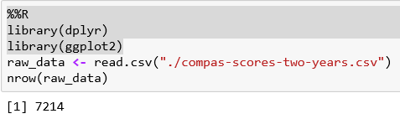
The variables are categorized first created from the collected data which personal data like name, age, sex, date of birth, race, criminal records, jail records, incarceration records, screening dates. Second assigned by user which ID, derived columns for collected data like first name, last name, age category or generated by algorithms like type of assessment, calculate data like start, end, event, two_year_recid. Third generated by algorithms which COMPAS scores for recidivism like decile_score, score_text and violent recidivism like v_decile_score, v_score_text.
Next import R modules ggplot and dplyr to implement predictive maintenance, after that read the non-violent dataset to output the number of rows.
Next remove rows first if the charge date of a defendants COMPAS scored crime was not within 30 days from when the person was arrested, we assume that for the data quality reasons, we do not have the right offense. Second, we coded the recidivist flag is_recid to be -1 if we could not find a COMPAS case at all. Third those c_charge_degree with a ‘O’ which is ordinary traffic offenses will not result in Jail time are removed. Forth we filtered the underlying data from Broward country to include only those rows representing people who either recidivated in two years or had at least two years outside of a jail.

After the data cleaning, the observations drop from 7,214 to 6,172.
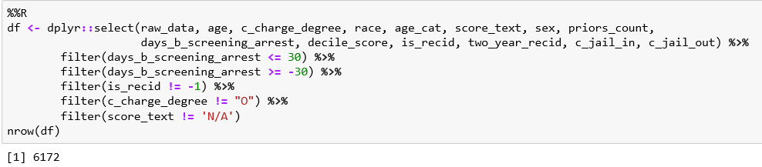
Next the data exploration, we analyze the correlation between recidivism scores and jail period, the result of recidivism scores is weakly correlated to jail period is 0.207. Next, we analyze the demographic breakdown between univariate like age_cat, race, score_text, sex, two_year_recid and bivariate like sex vs race.
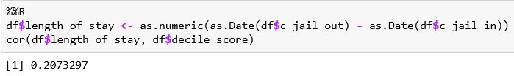
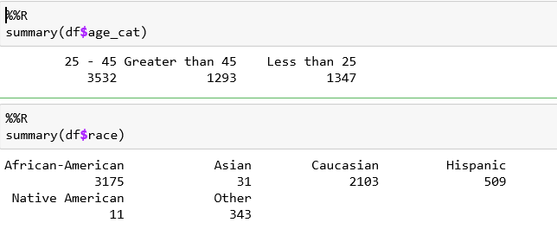
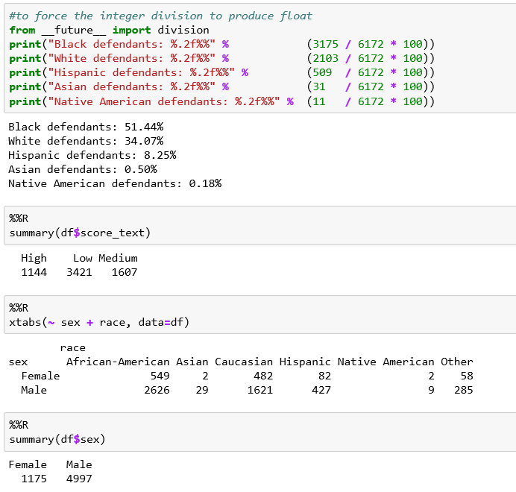

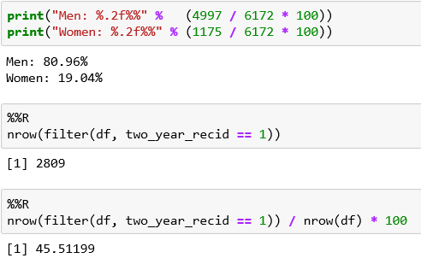
Next the visualization, we plot the simple distribution of COMPAS recidivism decile scores for defendants among whites and blacks. Next, we tabulate all defendants with respect to COMPAS decile score for recidivism. The histograms show that the scores for white defendants were skewed toward lower-risk categories, while the black defendants were evenly distributed across scores. In our two-year sample, there were 3,175 black defendants and 2,103 white defendants, with 1,175 female defendants and 4,997 male defendants. There were 2,809 defendants who recidivated within two years in this sample.
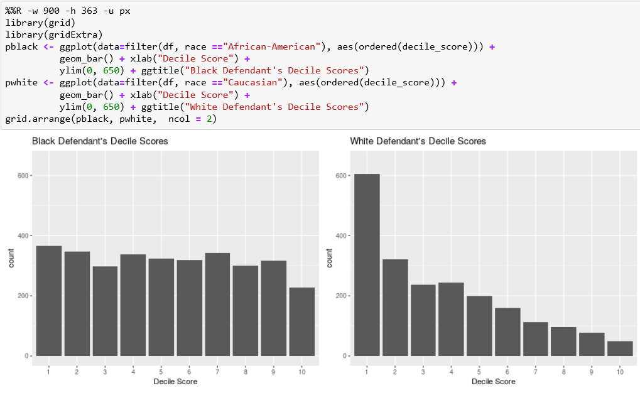
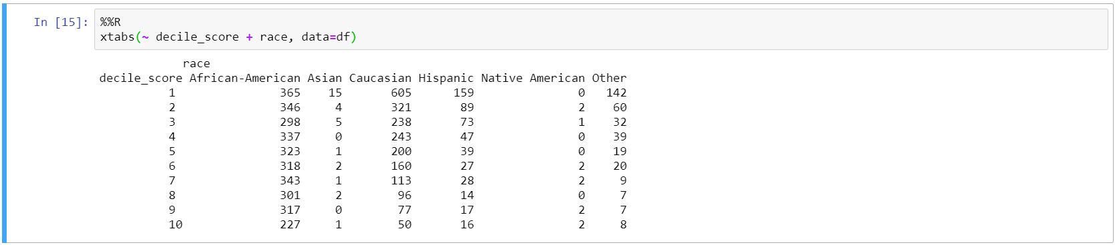
Next the data analysis to test racial disparities in the score controlling for other factors, we created a logistic regression model that considered race, age, criminal history, future recidivism, charge degree, gender, and age. We used those factors to model the odds of getting a higher COMPAS score.
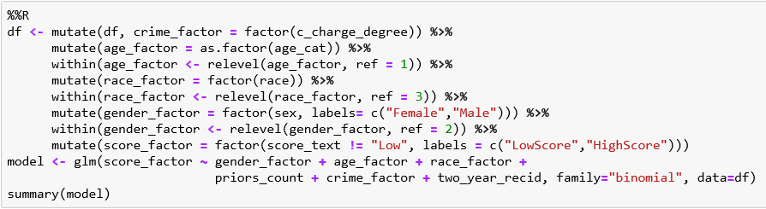
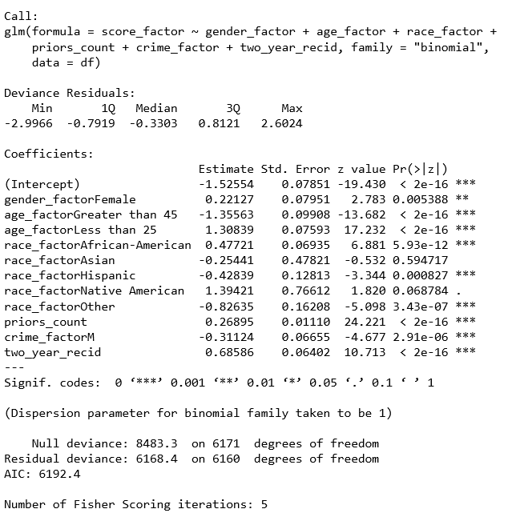
In summary, our logistic model found the most predictive factor of a higher risk score was age. Defendants younger than 25 years old were 2.5 times as likely to get a higher score than middle aged offenders, even when controlling for prior crimes, future criminality, race, and gender. Next race was also quite predictive of a higher score, while Black defendants had higher recidivism rates overall when adjusted for this difference and other factors, they were 45% more likely to get a higher score than whites. Next the female defendants were 19.4% more likely to get a higher score than men, controlling for the same factors.
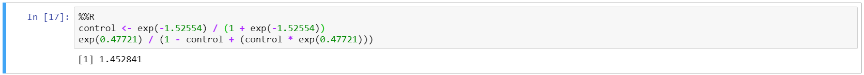
- Screenshots of each task of Task 3
- Screenshots of each task of Task 4
The datasets we used in this task is ‘compas-scores-two-years-violent.csv’. It has 4,743 rows; each row represents a person with 54 variables (columns). The variables are categorized first created from the collected data which personal data like name, age, sex, date of birth, race, criminal records, jail records, incarceration records, screening dates. Second assigned by user which ID, derived columns for collected data like first name, last name, age category or generated by algorithms like type of assessment, calculate data like start, end, event, two_year_recid. Third generated by algorithms which COMPAS scores for recidivism like decile_score, score_text and violent recidivism like v_decile_score, v_score_text.
We remove rows if the charge date of a defendants COMPAS scored crime was not within 30 days from when the person was arrested, we assume that of the data quality reasons, we do not have the right offense. Second, we coded the recidivist flag is_recid to be -1 if we could not find a COMPAS case at all. Third those c_charge_degree with a ‘O’ which is ordinary traffic offenses will not result in Jail time are removed. Forth we filtered the underlying data from Broward country to include only those rows representing people who either recidivated in two years or had at least two years outside of a jail.
After the data cleaning, the observations drop from 4,743 to 4,020.
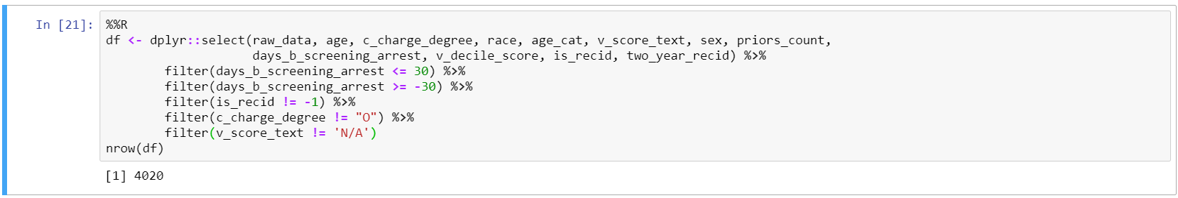
Next the data exploration, we analyze demographic breakdown of univariate which is age_cat, race, score_text and two_year_recid.
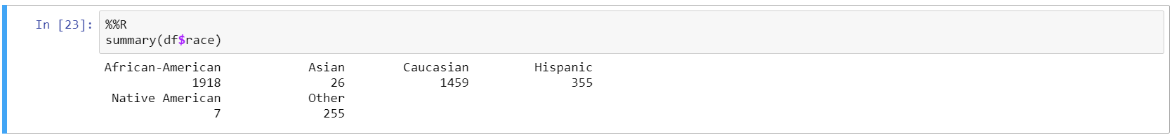
Next the visualization, we plot the simple distribution of COMPAS violent recidivism decile score for defendants among whites and blacks.
The histograms for COMPAS’s violent risk score also show a disparity in score distribution between white and black defendants. The sample we used to test COMPAS’s violent recidivism score was slightly smaller than the general recidivism score which is 4,020 defendants, 1,915 black defendants and 1,459 white defendants. There are 652 violent recidivists.
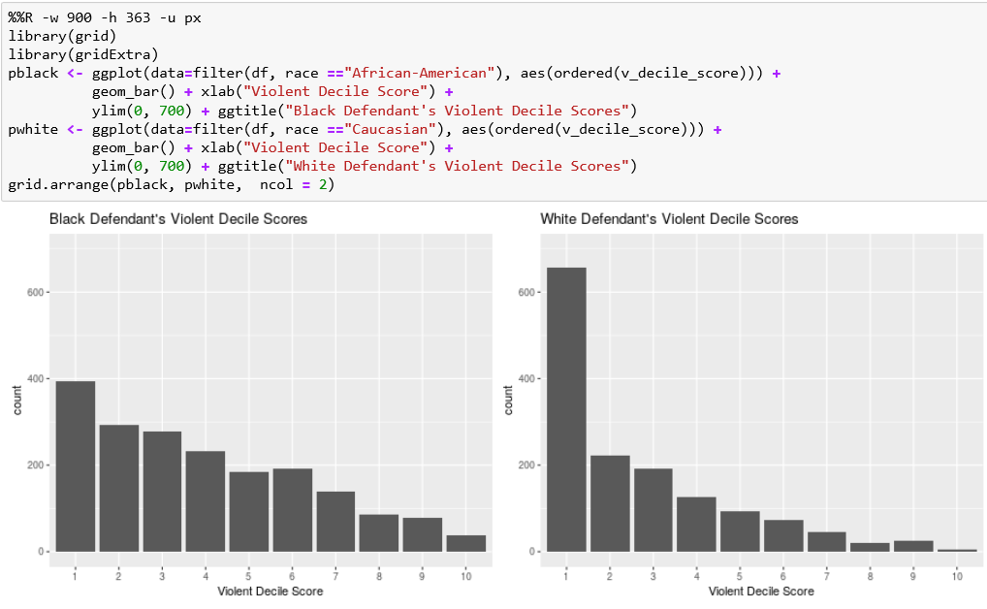

Next the data analysis, we analyzed 4,020 people who scored for violent recidivism over a period of two years not including time spent incarcerated. We ran our logistic regression model with same set of predictors as earlier.
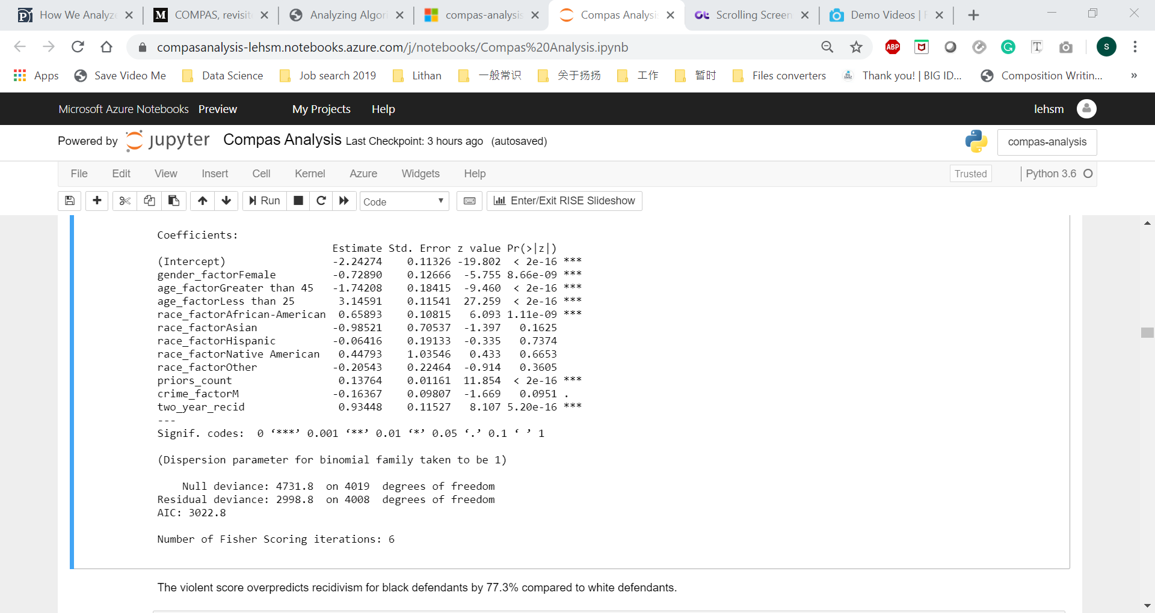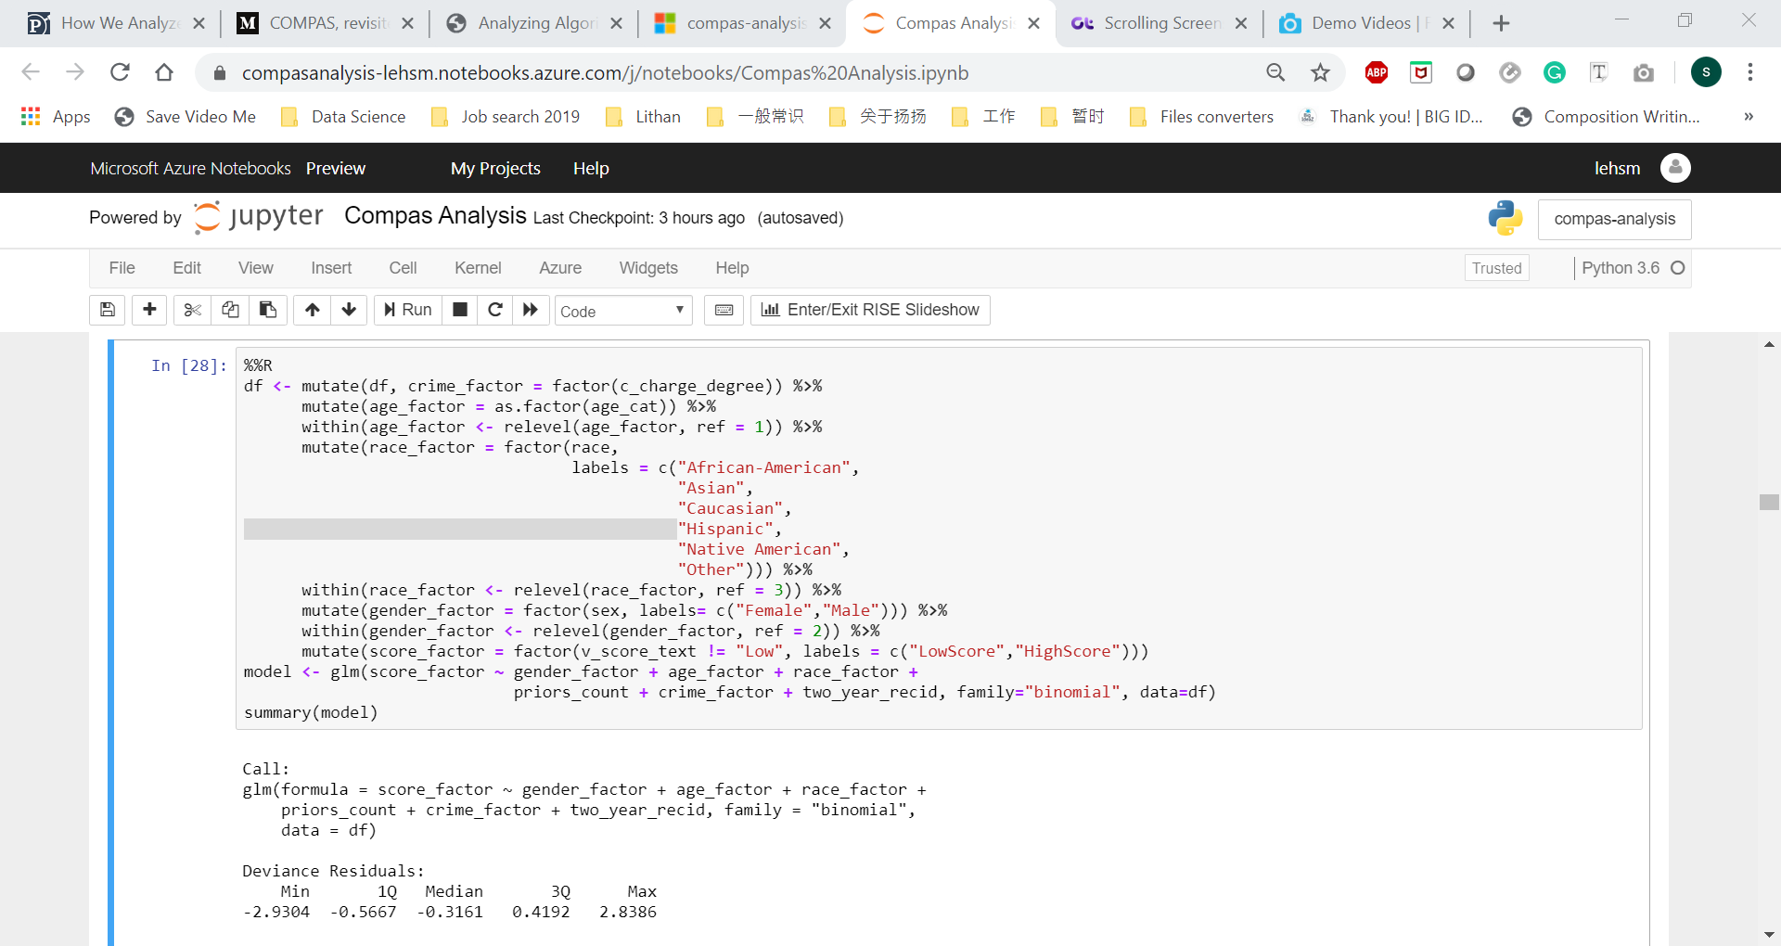
In summary age was an even stronger predictor of a higher score for violent recidivism. Our regression showed that defendants under 25 were 7.4 times more likely to get a higher score than middle age defendants, when correcting for criminal history, gender, race, and future violent recidivism. Race was also predictive of a higher score for violent recidivism. Black defendants were 77.3% more likely than white defendants to receive a higher score, correcting for criminal history and future violent recidivism.

- Screenshots of each task of Task 5
The datasets used for this task is ‘cox-parsed.csv’. It has 13,419 rows; each row represents a person with 52 variables (columns).
Next for the data cleaning, we remove people when they were incarcerated. Due to the erroneous jail data, we filter out the rows that have an end date more than the start date.
After the data cleaning, the observations drop from 13,419 to 10,314.
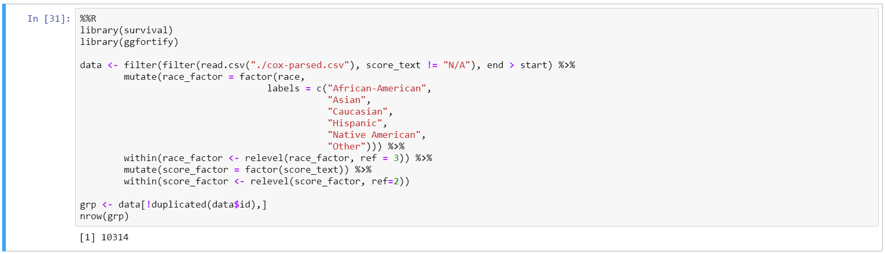
Next for the data exploration, we analyze demographic breakdown of univariate analysis which is score_factor and race_factor.
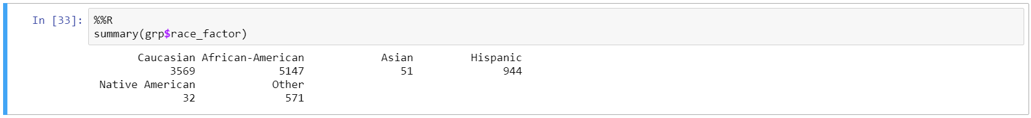
Next the data analysis is to test COMPAS’s predictive accuracy, we fit a cox proportional hazards model to the respective data. A cox model allows us to compare recidivism rate while controlling for time.
Across every risk category, black defendants recidivated at higher rate accordingly to race specific Kaplan Meier plots. The race specific models have similar concordance values of 62.5% for whites and 62.3% for blacks.
The cox proportional hazards model is essentially a regression model commonly used statistical in medical research for investigating the association between the survival time of patients and one or more predictor variables.
Due to the errors in the underlying jail data, we need to filter out 32 rows that have an end date more than the start date. Considering that there are 13,334 total rows in the data, such a small number of errors will not affect the results.
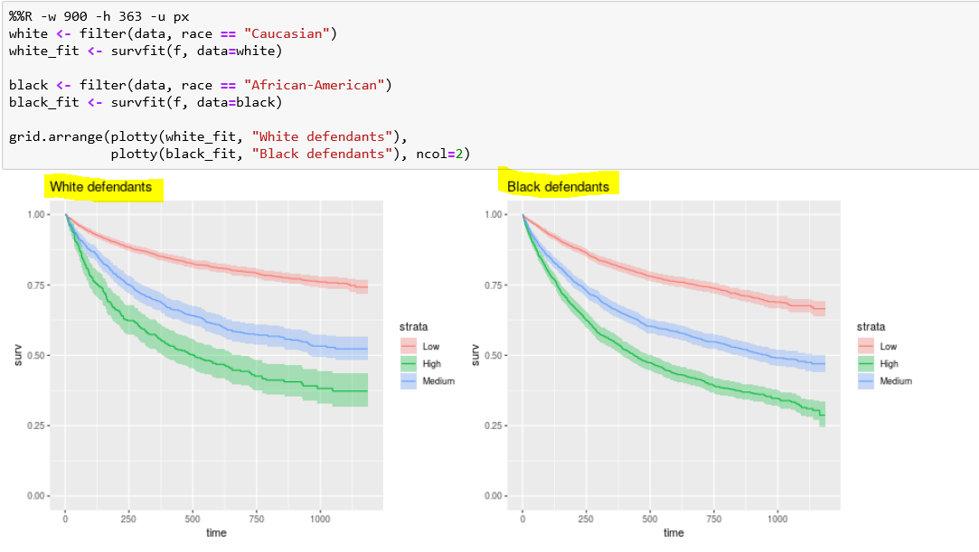
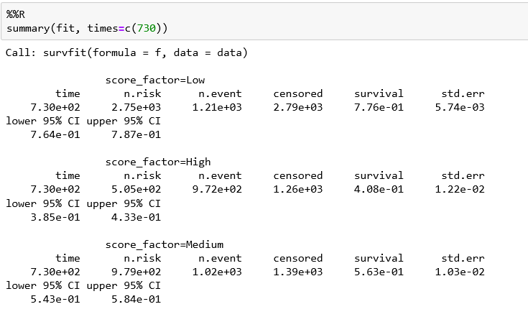
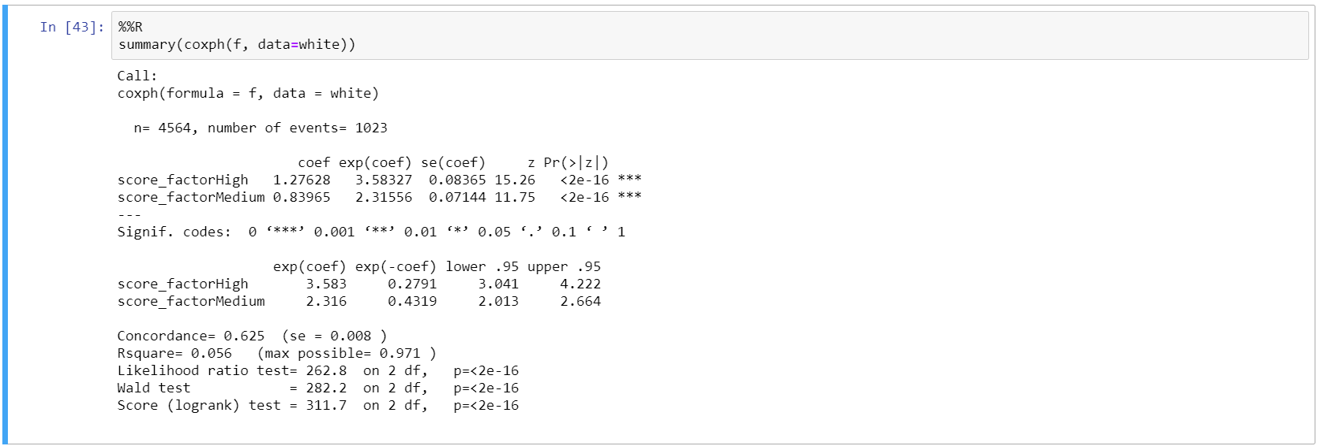

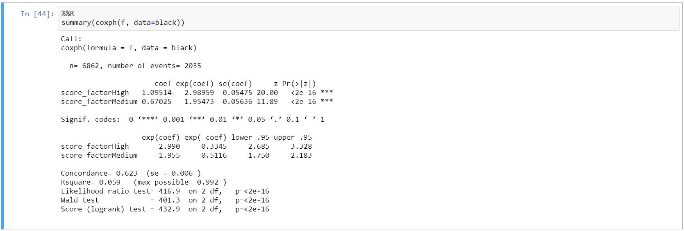
- Screenshots of each task of Task 6
On the above analysis shows that the COMPAS algorithm does overpredicts African American defendant’s future recidivism, we will want to explore the direction of the bias. We can discover differences in overprediction and underprediction by comparing COMPAS scores across racial lines. Overall, the false positive rate is 32.35%. The number is higher for African Americans at 44.85% while lower for whites at 23.45%. This implies that under COMPAS black defendants are 91% more likely to get a higher score and not go on to commit more crimes than white defendants after two year. The COMPAS scores misclassify white reoffenders as low risk at 70.4% more often than black reoffenders.
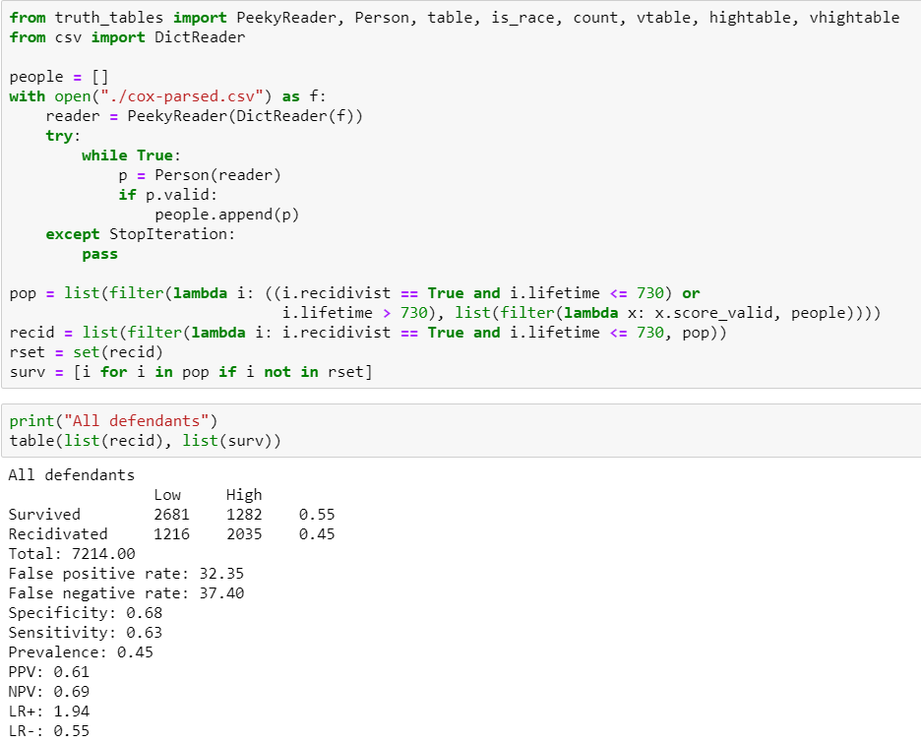

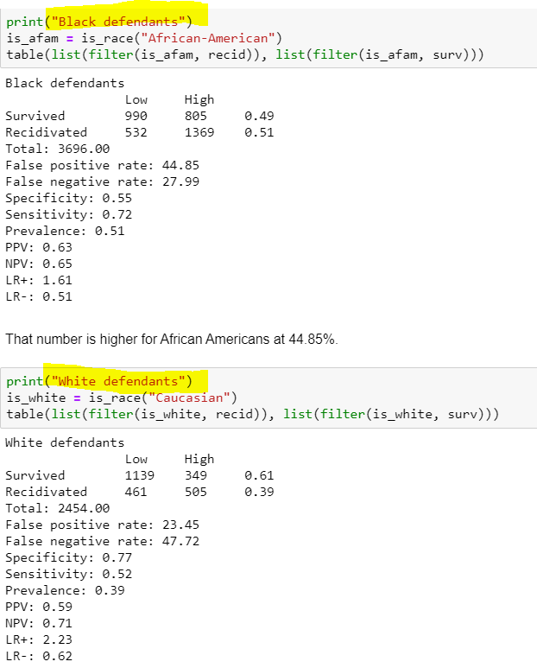
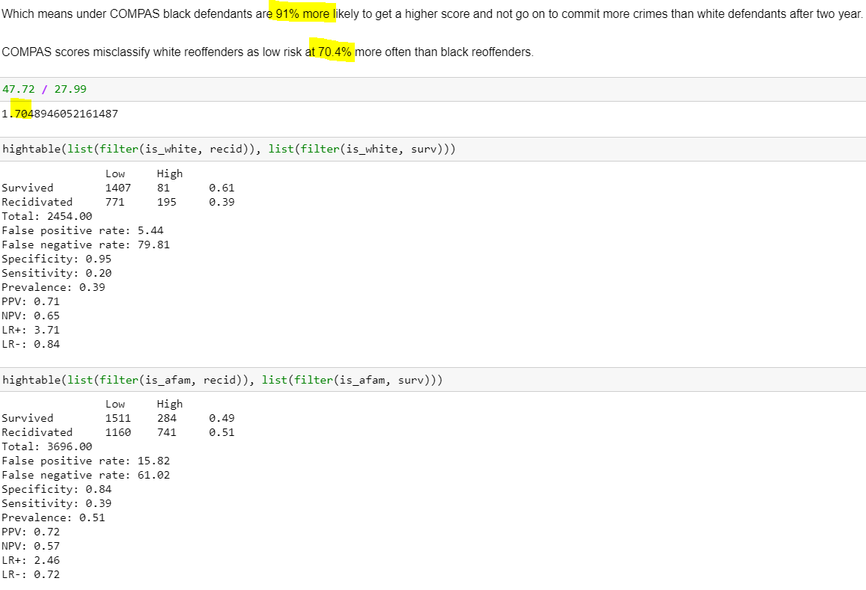
- Screenshots of each task of Task 7
The dataset for this task is “cox-violent-parsed.csv”. It has 18,316 rows; each row represents a person with 52 variables (columns). Overall, there are far fewer violent recidivists than general recidivists and there is not a clear difference in the hazard rates across score levels for black and white recidivists. These Kaplan Meier plots show very low rates of violent recidivism. However, relatively black defendants are twice as likely to be false positive for a higher violent score than white defendants. White defendants are 63% more likely to get a lower score and commit another crime than Black defendants.
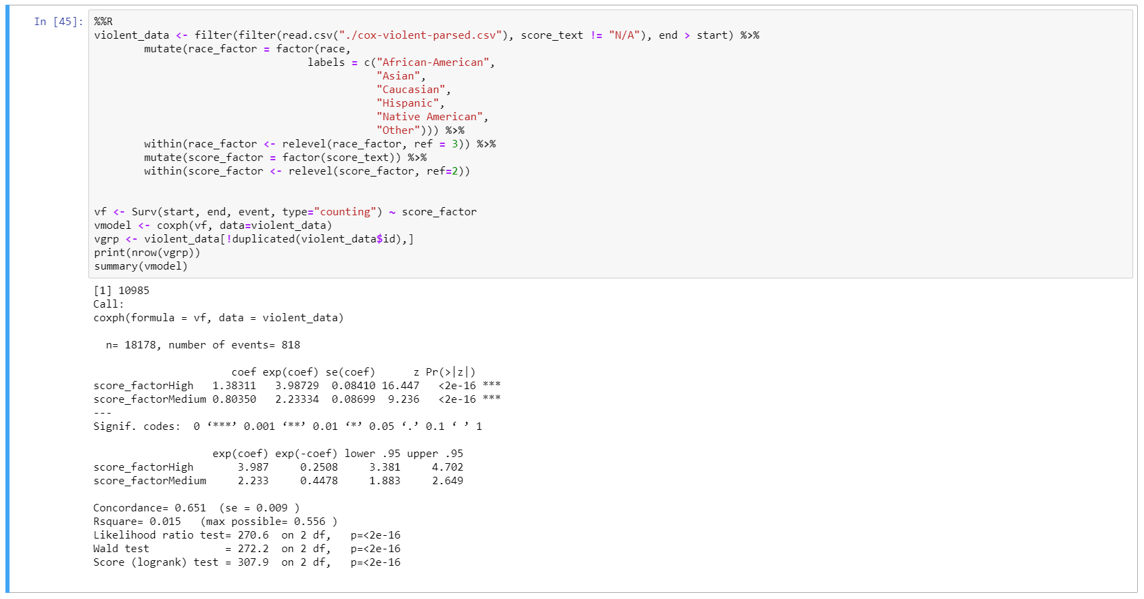
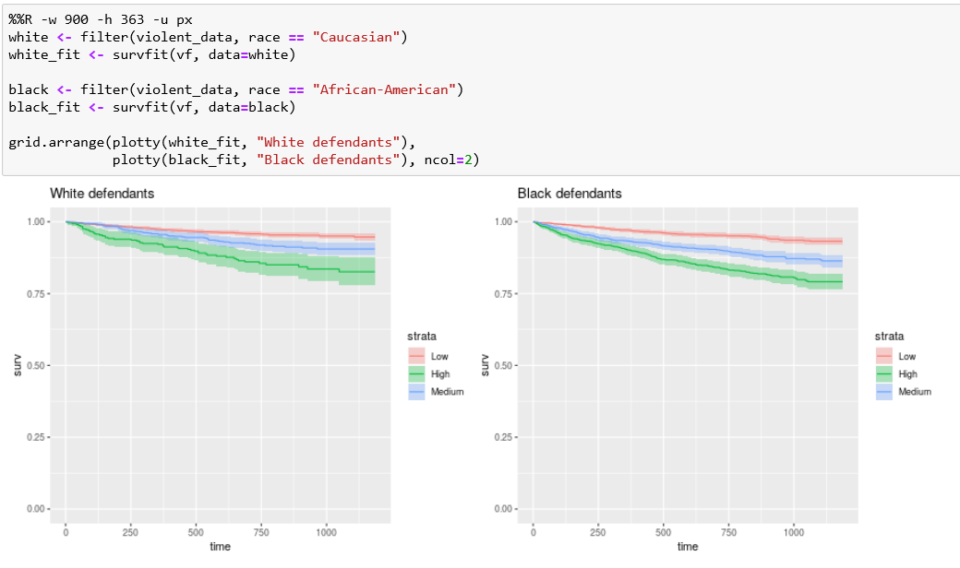
In terms of underlying recidivism rates, we can look at gender specific Kaplan Meier estimates. There is a striking difference between women and men. As the plots show, the COMPAS score treat a high-risk woman the same as a medium risk man.
